ECEN 4/5632 Theory and Application of Digital Filters Fall 2026
9-4-26 P. Mathys

Problem Set 2: Solution
1. Sinusoid through an LTI system
An LTI system has $H(e^{jω})=1+0.5e^{-jω}$. The input is $x[n]=2cos(πn/3+π/4)$.
a) Evaluate $H(e^{jπ/3})$ in rectangular form.
b) Find its magnitude and phase.
c) Write the steady-state output $y[n]$ in cosine form.

2. DTFT shifting and a spectral zero
Let $x[n]={\left(0.5\right)}^{n} u[n]$ and $y[n]=x[n-2]-x[n]$.
a) Find $X(e^{jω})$.
b) Use the time-shift property to find $Y(e^{jω})$.
c) Evaluate $Y(e^{j0})$ and explain what that value says about the sum of $y[n]$.

3. Difference equation to frequency response
A causal system satisfies $y[n]-0.8y[n-1]=x[n]-x[n-1]$, with zero initial conditions.
a) Derive $H(e^{jω})$.
b) Evaluate $H$ at $ω=0$ and $ω=π$.
c) Based only on those values and the structure of the numerator, is the system more “low-pass-like” or “high-pass-like”? Explain.
d) Use scipy.signal.freqz to check your reasoning.

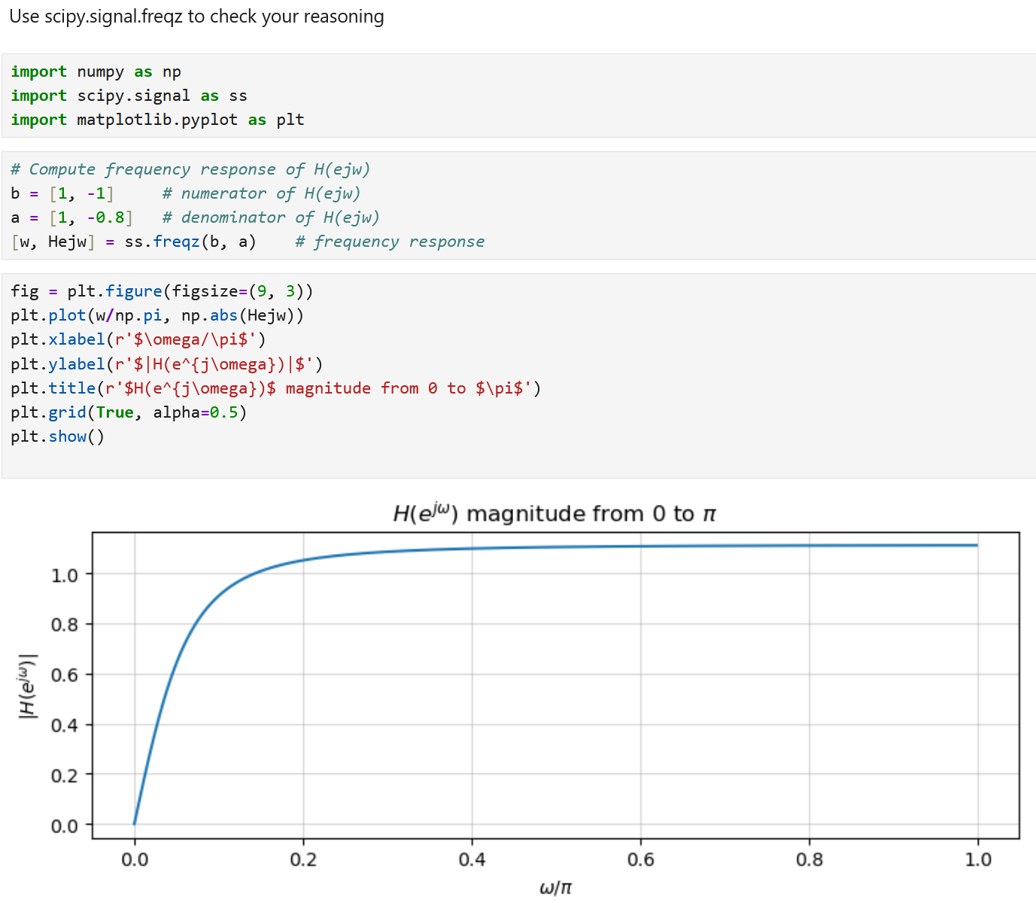

4. From continuous frequency to discrete frequency
A microphone voltage is $x_{c}(t) = 2 cos(2π·1000 t) + cos(2π·5000 t)$. It is sampled at $f_{s} = 16$ kHz.
a) Write $x[n]$ explicitly.
b) Give the two discrete-time angular frequencies in rad/sample and as multiples of $π$.
c) Are either components aliased at this sample rate? Explain.

5. Spectral replicas and Nyquist margin
An analog signal is strictly bandlimited to $|f| ≤ 3.4$ kHz and is sampled at $f_{s} = 8$ kHz.
a) Sketch or describe the locations of the baseband spectrum and the first two pairs of replicas after ideal sampling.
b) What is the separation between adjacent spectral replicas?
c) What guard-band width exists between the positive edge of the baseband copy and the nearest edge of the $+f_{s}$ replica?
d) What is the ideal Nyquist rate for this signal? Is 8 kHz above it?

6. Downsampling audio: Filter first
A recording is sampled at 48 kHz and contains useful content up to 18 kHz. You want a 16 kHz output by downsampling by 3.
a) What is the new Nyquist frequency?
b) Why is keeping every third sample without filtering incorrect?
c) What band must be strongly attenuated before downsampling?
d) If an 11 kHz sinusoid is present and you downsample naively to 16 kHz, at what frequency does it appear?

7. Prove two analog sinusoids give the same samples (ECEN 5632 problem)
At $f_{s} = 12$ kHz, compare $x_{1}(t)=cos(2π·2000t)$ and $x_{2}(t)=cos(2π·10000t)$.
a) Write $x_{1}[n]$ and $x_{2}[n]$.
b) Use a trigonometric or complex-exponential identity to prove $x_{1}[n]=x_{2}[n]$ for every integer $n$.
c) Explain in one sentence why this proves aliasing cannot generally be undone after sampling.

